Name:________________________________________________________________________

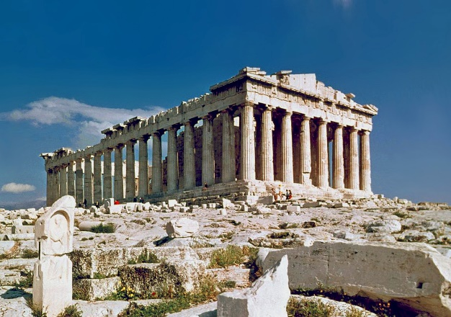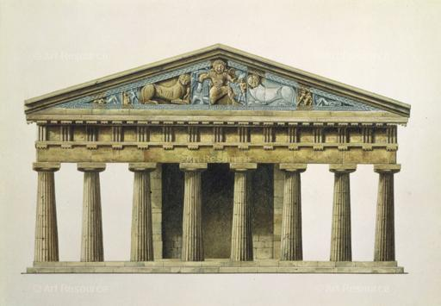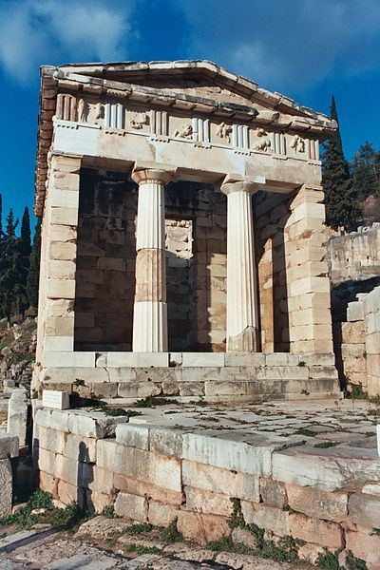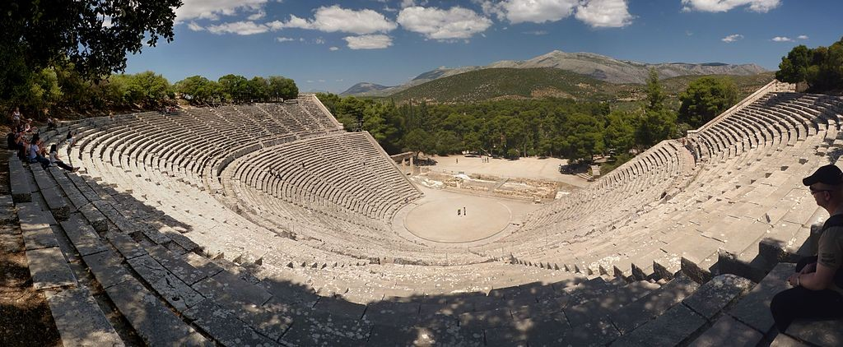

# Instructions

1. Choose an event, a god/goddess or some other aspect of Ancient Greece, and **write it below**:

My monument will be dedicated to ____________________________________________________________________________________

1. **Sketch** a monument design dedicated to whatever you chose on the back of this paper – use abstraction to think about how your architecture relates to your topic!
2. **Create your monument** in 3D using TinkerCad: tinkercad.com
3. In a Google Doc, paste the link to to your TinkerCad design and **write** **at least two paragraphs** to accompany your design describing how you came up with the idea and how your monument relates to your topic

# Sketch your monument design here

# Rubric

|  |  |  |  |  |
| --- | --- | --- | --- | --- |
|  | Doesn’t meet expectations [0] | Approaching expectations [1-4] | Meets expectations [5-8] | Exceeds expectations [9-10] |
| Sketch | Sketch not completed | Sketch is not understandable  Sketch doesn’t relate to 3D model | Sketch is understandable  Sketch was used while creating 3D model | Sketch is clear and well thought out  Sketch closely aligns with 3D model |
| 3D monument | 3D monument not completed | 3D monument uses fewer than five elements  3D monument does not reflect Ancient Greek style | 3D monument uses between five and ten elements  3D monument could be seen as using Ancient Greek style | 3D monument uses more than ten elements  3D monument is a clear reflection of Ancient Greek style |
| Written explanation | Written explanation not completed | Written explanation shorter than two full paragraphs  Written explanation does not connect chosen topic with monument | Written explanation is at least two paragraphs  Written explanation makes some attempt to connect chosen topic with monument | Written explanation is at least two well-structured paragraphs  Written explanation clearly connects chosen topic with monument |
| Creativity and effort | Total lack of creativity or effort | Some creativity is seen across all elements  Some components show signs of effort | Creativity is seen across all elements  All elements show signs of effort | All elements are exceptionally creative and clearly took a great deal of effort |

# Score : _____ / 40